Step 1: Dynamic Web Project create pannunga
- Eclipse open pannunga.
- File → New → Dynamic Web Project click pannunga.

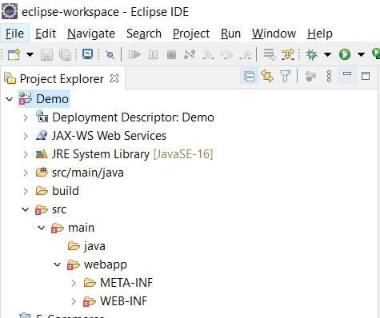

Project Name: HitCountProject
- Target Runtime: Apache Tomcat v10.1
- Dynamic Web Module Version select panna option irundha 6.0 select pannunga.
- Next → Next → Finish click pannunga.
Step 2: hitcount.jsp create pannunga

1. Project Explorer-la HitCountProject expand pannunga.
2. src/main/webapp folder irundha adha right-click pannunga. Illaina WebContent folder-a right-click pannunga.

3. New → JSP File click pannunga.

4. File name-la hitcount.jsp enter panni Finish click pannunga.
Step 3: Correct code paste pannunga
Ungal code-la oru small mistake irukku. session.setAttribute() comment-kulla irukku. Adhanala hit count session-la save aagadhu. Indha corrected code use pannunga.

<%@ page language="java" contentType="text/html; charset=UTF-8"
pageEncoding="UTF-8" %>

<!DOCTYPE html>
<html>
<head>
<meta charset="UTF-8">
<title>Page Hit Counter</title>
</head>
<body>

<%
Integer hits = (Integer) session.getAttribute("hitCount");

if (hits == null) {
hits = 1;
} else {
hits = hits + 1;
}

// Store the updated count in the session
session.setAttribute("hitCount", hits);
%>

<h2>JSP Session Hit Counter</h2>

<p>
You have visited this page
<b><%= hits %></b>
time(s) during this session.
</p>

<p>Session ID: <%= session.getId() %></p>

</body>
</html>

